**Chapter 3 Substituent effects on the 1H and 13C NMR chemical shifts on**

**the 4′-substituted 5-benzylidenebarbituric acid.**

**3.1 Introduction**

Correlation of the chemical shift with substituent constant has been widely used to investigate the nature of the effect of the substituent on the physical properties of compounds. Electron density around the nucleus of interest (H, C) is mostly affected by the electron-donating and electron-withdrawing ability of the substituent.

Therefore, a correlation between the observed chemical shift and any parameters representing such ability seems to be well-founded and there are numerous reports on the subject1.

The most successful and intensively investigated are the linear free energy relationship with the Hammett equation2,3,4 as the most predominant example.

The single substituent parameter (SSP) approach which is represented by equation (3.1) has been used to correlate the chemical shift of *m-* and *p-* substituted compounds to unsubstituted compound using the Hammett *σm*and *σp* values. Values of 13C were reported for the system of *m*- and *p*- substituted cinnamic acids.2

*δ = ρσ + δo* (3.1)

The dual substituent parameter (DSP) approach, on the other hand, divides the effect of a substituent into inductive (σI) and resonance (σR) parameters as represented in equation (3.2).

*δ = ρIσI + ρRσR +* δo (3.2)

The substituent constant σ measures the polar effect of the substituent and is, in principle, independent of the nature of the reaction. The reaction constant *ρ* depends on the nature of the reaction and measures the susceptibility of the reaction to polar effects of the substituents.

Electron withdrawing substituents have positive values of σ and electron releasing substituents have negative values. The σ- scale covers roughly the numerical range 0±1.4 The reaction constant ρ measures the susceptibility of the reaction to the influence of substituents.

Yukawa and Tsuno5 proposed equation (3.3) for dealing with the influence of +M substituents on reactions which are more electron demanding than the ionization of benzoic acid.

*δ = ρσ +*r (*σ*+ - *σ*- ) *δo* (3.3)

The DSP analysis of sterically congested systems has been improved by TSP by using Charton’s steric parameter (ν) using equation (3.4).

*δ = ρI σI + ρR σR + φν + δo* (3.4)

The DSP equation (3.2) is the most generally useful treatment and is well-suited for the analysis of spectroscopic data. In equation (3.2), the derived *ρI* and *ρR* values which are position dependent, give a direct measure of the relative transmission of inductive and resonance effects. Due to the independence of the *ρI* and *ρR* transmission coefficients, DSP method represents a general approach for the correlation of substituent effects over a large range of different mechanisms. Their relative importance may change from one system to another.

The relative importance of the resonance and inductive effects is expressed by blending factor (λ) obtained as the ratio of the coefficients r and f or *ρR*and *ρI*.

**3.2** **Recent studies on substituent effects on 1H and 13C NMR chemical shifts**

G.F. Fadhil and A.H. Essa6 studied 13C NMR chemical shifts of substituted benzylidene anilines. The benzylidene substituent dependence of δC (C=N) was used as a tool to study electronic substituent effects on azomethine unit. The benzylidene substituents X have a reverse effect on δC (C=N); electron-withdrawing substituent cause shielding, while electron donating ones do the reverse, the resonance effects clearly predominating over the inductive effects.

R.Arulkumaran *et al.*7 reported on IR and NMR chemical shifts of substituted cyanopyridine. NMR chemical shifts were correlated with Hammett substituent constants using single and multi-linear regression constants.

R.Arulkumaran and coworkers8 synthesized substituted (E)-1-benzylidene-2-(diphenylmethylene) hydrazine compounds. They were characterized by UV, IR and NMR spectral data. These data are correlated with Hammett substituent constants and Swain-Lupton F and R parameters using single and multi-linear regression analysis.

G. Thirunarayanan *et al.*9 synthesized substituted aryl benzohydrazides which were analyzed by spectral data. These data were correlated with Hammett substituent constants and Swain-Lupton parameters using single and multi-linear regression analysis.

M.Rajarajan and co-workers10 reported UV, IR and NMR chemical shifts of substituted (E)-1-benzylidene-2-(4-bromophenyl) hydrazines. The spectral data have been correlated with various Hammett substituent constants and Swain-Lupton F and R parameters using single and multi-regression analysis.

Aleksandar D. Marinkovic *et al.*11 studied the substituent effect on IR,1H and 13C NMR spectral data of N-(substituted phenyl)-2-cyanoacetamides. A variety of substituents were employed for phenyl substitution and fairly good correlations were obtained using the simple Hammett and Hammett-Taft dual substituent parameter equations.

G.Thirunarayanan and co-workers12 reported the substituent effect on IR and NMR spectral data in 4-bromo-1-naphthyl chalcones. These spectral data are correlated with various Hammett substituent constants. From the results of statistical analysis, the effect of substituents explained.

G. Thirunarayanan13 synthesized a series of diimines and studied correlation analysis of IR and NMR spectral data. The data were correlated with Hammett substituent constants and Swain-Lupton F and R parameters using single and multi-linear regression analysis.

**3.3 Purpose and scope**

In this study, the 4′-substituted-5-benzylidenebarbituric acids Fig (3.1)



**Figure 3.1**

were prepared with the following objectives.

1. To study the correlations using the Hammett substituent constants and 1H NMR substituent induced chemical shifts (SCS) of substituted-5-benzylidenebarbituric acids.
2. To study the correlations using the Hammett substituent constants and 13C NMR substituent induced chemical shifts (SCS) of substituted-5-benzylidenebarbituric acids.
3. To study the use of SCS to monitor the transmission of electronic effects in molecular structures and to understand the mode of transmission of long-range effects in extended π-systems.

**3.4 Results and discussion**

**3.4.1 Substituent effects on the 1H NMR chemical shifts of the**

**5-benzylidenebarbituric acid**

**3.4.1.1 H1 – Hydrogen atom**

The chemical shift of H1  hydrogen (Table 3.1) appeared over a narrow range of 0.159 ppm. The SSP analysis of H1 hydrogen atom gave good correlations with σp, σpo, σp+, σp+/ σp- (Table 3.2). The best fit of SSP analysis is given in equation (3.5). The plot of log δH1 vs *σp+* is shown in Fig. (3.2).

log δ H1 **=** 0.004 *σp+* + 1.05 (3.5)

(±0.001)

r = 0.975; s = 0.001; F = 27.35; n =6

The DSP analysis is given in table (4.3) and the best fit of DSP analysis is given in equation (3.6).

log δH1  = 0.004 *F* + 0.008 *R* + 1.051 (3.6)

(±0.002) (±0.001) (0.001)

R = 0.966; SE = 0.001; F = 27.96; n = 7

**Table 3.1:** 1H NMR chemical shifts of 4′-substituted 5-benzylidenebarbituric acids

|  |  |  |  |  |  |
| --- | --- | --- | --- | --- | --- |
| S.No. | Substituent, -X | H1 | H3 | H7 | H3′5′ |
|  |  |  |  |  |  |
| 1. | -OCH3 | 11.175 | 11.302 | 8.252 | 7.065 |
|  |  |  |  |  |  |
| 2. | -OH | 11.117 | 11.249 | 8.213 | 6.878 |
|  |  |  |  |  |  |
| 3. | -CH3 | 11.218 | 11.365 | 8.255 | 7.304 |
|  |  |  |  |  |  |
| 4. | -H | 11.238 | 11.397 | 8.285 | 7.485 |
|  |  |  |  |  |  |
| 5. | -Cl | 11.275 | 11.425 | 8.243 | 7.518 |
|  |  |  |  |  |  |
| 6. | -Br | 11.272 | 11.421 | 8.223 | 7.670 |
|  |  |  |  |  |  |
| 7. | -NO2 | 11.329 | 11.504 | 8.324 | 8.245 |

**Table 3.2:** Results of statistical treatment of 1H – Chemical shift with σp,σpo,

σp+, σp+/ σp, σp+/ σp-, σp+/ σp/ σp- substituent constants using single

parameter equation (3.1)

|  |  |  |  |  |  |  |  |  |
| --- | --- | --- | --- | --- | --- | --- | --- | --- |
| **S.No** | **Protons** | **Scale** | **ρ** | **r** | **s** | **F** | **log δo** | **n** |
| 1 | H1 | *σP* | 0.007±0.001 | 0.940 | 0.001 | 38.04 | 1.050±0.001 | 7 |
|  | *σPO* | 0.005±0.001 | 0.934 | 0.001 | 27.35 | 1.050±0.001 | 6 |
|  | *σP+* | 0.004±0.001 | 0.975 | 0.001 | 99.39 | 1.050±0.001 | 7 |
|  | *σP+/ σP* | 0.005±0.001 | 0.877 | 0.001 | 16.67 | 1.050±0.001 | 7 |
|  | *σP+/ σP-* | 0.003±0.001 | 0.942 | 0.001 | 39.58 | 1.051±0.001 | 7 |
|  | *σP+/ σP/ σP-* | 0.004±0.001 | 0.856 | 0.001 | 13.72 | 1.050±0.001 | 7 |
|  |  |  |  |  |  |  |  |  |
| 2 | H3 | *σP* | 0.008±0.001 | 0.948 | 0.001 | 44.25 | 1.055±0.001 | 7 |
|  | *σPO* | 0.006±0.001 | 0.917 | 0.001 | 21.26 | 1.055±0.001 | 6 |
|  | *σP+* | 0.005±0.001 | 0.999 | 0.0005 | 245.58 | 1.056±0.001 | 7 |
|  | *σP+/ σP* | 0.006±0.001 | 0.903 | 0.002 | 22.20 | 1.056±0.001 | 7 |
|  | *σP+/ σP-* | 0.004±0.001 | 0.962 | 0.001 | 62.96 | 1.056±0.001 | 7 |
|  | *σP+/ σP/ σP-* | 0.004±0.001 | 0.887 | 0.002 | 18.44 | 1.055±0.001 | 7 |
|  |  |  |  |  |  |  |  |  |
| 3 | H7 | *σP* | 0.003±0.002 | 0.658 | 0.002 | 3.81 | 0.917±0.001 | 7 |
|  | *σPO* | 0.003±0.002 | 0.550 | 0.002 | 1.74 | 0.916±0.001 | 6 |
|  | *σP+* | 0.002±0.001 | 0.679 | 0.002 | 4.27 | 0.917±0.001 | 7 |
|  | *σP+/ σP* | 0.002±0.001 | 0.535 | 0.002 | 2.01 | 0.916±0.001 | 7 |
|  | *σP+/ σP-* | 0.002±0.001 | 0.746 | 0.001 | 6.29 | 0.916±0.001 | 7 |
|  | *σP+/ σP/ σP-* | 0.002±0.001 | 0.650 | 0.002 | 3.66 | 0.916±0.001 | 7 |
|  |  |  |  |  |  |  |  |  |
| 4 | H3’5’ | *σO* | 0.057±0.016 | 0.838 | 0.02 | 11.81 | 0.865±0.006 | 7 |
|  | *σO\** | 0.052±0.007 | 0.966 | 0.007 | 56.20 | 0.864±0.003 | 6 |
|  | *Es* | -0.041±0.012 | 0.831 | 0.016 | 11.16 | 0.876±0.006 | 7 |

“n=6 means calculated without -OH group”

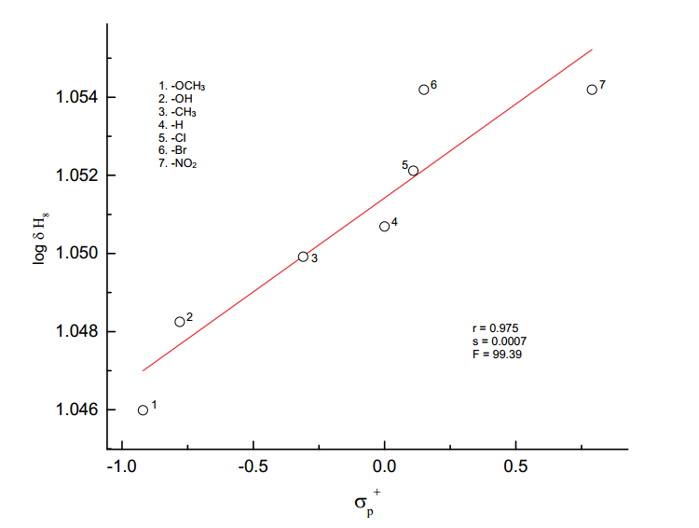

**log δ H1**

**Figure 3.2.** The plot of log δH1  vs *σp+*

**Table 3.3** DSP analysis of 1H-chemical shift with dual parameter equation (3.2)

|  |  |  |  |  |  |  |  |  |  |  |
| --- | --- | --- | --- | --- | --- | --- | --- | --- | --- | --- |
| **S.No** | **Protons** | **Scale** | ***ρI*** | ***ρR*** | **R** | **SE** | **F** | **log δo** | **n** | **λ=ρR/ρI** |
|
| 1 | H1 | *σI ,σR* | 0.005±0.002 | 0.008±0.002 | 0.879 | 0.002 | 6.88 | 1.051±0.001 | 7 | 1.60 |
|  |  | *σI ,σRo* | 0.005±0.002 | 0.003±0.002 | 0.838 | 0.001 | 3.54 | 1.056±0.001 | 6 | 0.60 |
|  |  | *σI ,σR+* | 0.002±0.002 | 0.002±0.002 | 0.609 | 0.003 | 1.18 | 1.050±0.003 | 7 | 0.66 |
|  |  | *σI ,σR-* | 0.004±0.002 | 0.003±0.002 | 0.883 | 0.001 | 5.31 | 1.050±0.001 | 6 | 0.75 |
|  |  | *F,R* | 0.004±0.002 | 0.008±0.001 | 0.966 | 0.001 | 27.96 | 1.051±0.001 | 7 | 2.00 |
|  |  |  |  |  |  |  |  |  |  |  |
| 2 | H3 | *σI ,σR* | 0.005±0.003 | 0.010±0.002 | 0.912 | 0.002 | 9.89 | 1.056±0.001 | 7 | 2.00 |
|  |  | *σI ,σRo* | 0.006±0.003 | 0.005±0.003 | 0.829 | 0.002 | 3.29 | 1.056±0.001 | 6 | 0.83 |
|  |  | *σI ,σR+* | 0.003±0.006 | 0.003±0.003 | 0.622 | 0.003 | 1.27 | 1.056±0.003 | 7 | 1.00 |
|  |  | *σI ,σR-* | 0.005±0.002 | 0.005±0.002 | 0.886 | 0.001 | 5.47 | 1.056±0.001 | 6 | 1.00 |
|  |  | *F,R* | 0.005±0.001 | 0.010±0.001 | 0.984 | 0.001 | 63.96 | 1.057±0.001 | 7 | 2.00 |
|  |  |  |  |  |  |  |  |  |  |  |
| 3 | H7 | *σI ,σR* | 0.001±0.003 | 0.005±0.003 | 0.711 | 0.002 | 2.05 | 0.917±0.001 | 7 | 5.00 |
|  |  | *σI ,σRo* | 0.001±0.001 | 0.006±0.001 | 0.923 | 0.001 | 8.50 | 0.917±0.001 | 6 | 6.00 |
|  |  | *σI ,σR+* | -0.001±0.004 | 0.002±0.002 | 0.384 | 0.002 | 0.35 | 0.918±0.002 | 7 | 2.00 |
|  |  | *σI ,σR-* | -0.001±0.001 | 0.005±0.001 | 0.905 | 0.001 | 6.85 | 0.918±0.001 | 6 | 50.00 |
|  |  | *F,R* | 0.001±0.002 | 0.005±0.002 | 0.783 | 0.002 | 3.17 | 0.917±0.001 | 7 | 8.33 |
|  |  |  |  |  |  |  |  |  |  |  |
| 4 | H3′5′ | *σI ,σR* | 0.047±0.015 | 0.077±0.015 | 0.950 | 0.010 | 18.69 | 0.873±0.007 | 7 | 1.60 |
|  |  | *σI ,σRo* | 0.057±0.025 | 0.041±0.024 | 0.851 | 0.020 | 3.93 | 0.868±0.011 | 6 | 0.66 |
|  |  | *σI ,σR+* | 0.030±0.004 | 0.023±0.021 | 0.684 | 0.020 | 1.76 | 0.872±0.022 | 7 | 0.66 |
|  |  | *σI ,σR-* | 0.042±0.015 | 0.047±0.012 | 0.951 | 0.010 | 14.96 | 0.871±0.006 | 6 | 1.25 |
|  |  | *F,R* | 0.049±0.006 | 0.073±0.005 | 0.992 | 0.040 | 132.74 | 0.874±0.003 | 7 | 1.40 |

“n=6 means calculated without -OH group”

**3.4.1.2 H3 – Hydrogen atom**

The chemical shift (Table 3.1) of H3 hydrogen atom shows a range of about 0.255 ppm. The result of SSP analysis shown in the table (3.2), affords an excellent correlation by *σp+* constant given in equation (3.7), and the plot of log δ H10 vs *σp+* is shown in Fig. (3.3).

log δ H3  = 0.005 *σp+* + 1.056 (3.7)

(±0.001) (±0.001)

r = 0.999; s = 0.0005; F = 245.58; n = 7

The DSP analysis in the Table (3.3), affords an excellent correlation as shown in equation (3.8).

log δ H3  = 0.005 *F* + 0.010 *R* + 1.057 (3.8)

(±0.001) (±0.001) (0.001)

R = 0.984; SE = 0.001; F = 63.96; n = 7

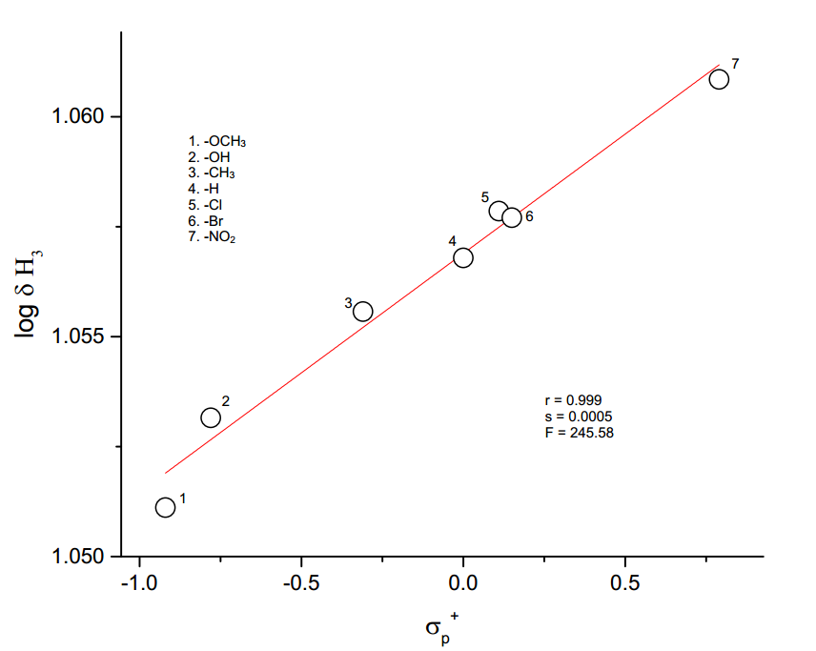

**Figure 3.3.** The plot of log δH3 vs *σp+*

**3.4.1.3 H7 – Hydrogen atom**

The chemical shift (Table 3.1) of H7 hydrogen appeared over a relatively very narrow range

of 0.111 ppm. The SSP analysis of H7 hydrogen atom gave poor correlation with *σp****,*** *σp+/ σp-,*

*σp+/ σp/ σp-* (Table. 3.2). The best fit of SSP analysis is given in equation (3.9).

log δH7 **=** 0.002 *σp+/ σp-* + 0.916 (3.9)

(±0.001) (±0.001)

r = 0.746; s = 0.001; F = 6.29; n = 7

The result of DSP analysis is given in Table (3.3) and the best fit of DSP analysis is given in equation (3.10).

log δ H7 **=** 0.001 *σI* + 0.006 *σRo* **+** 0.917 (3.10)

(±0.001) (±0.001) (±0.001)

R = 0.923; SE = 0.001; F = 2.05; n = 6

**3.4.1.4 H3′5′ – Hydrogen atom**

The chemical shift of H3′5′ hydrogen atom shows a range of about 1.367 ppm. The result of SSP analysis shown in the Table (3.2), affords a satisfactory correlation with σo* constant is given in equation (3.11).

log δ H3′5′  = 0.052 *σo\** + 0.865 (3.11)

(±0.007) (±0.003)

r = 0.966; s = 0.007; F = 56.20; n = 6

The result of DSP analysis is given in Table (3.3) and the best fit of DSP analysis is given in equation (3.12).

log δ H3′5′  = 0.049*F* + 0.073*R* + 0.874 (3.12)

(±0.006) (±0.005) (±0.003)

R = 0.992; SE = 0.04; F = 132.74; n = 7

The result of TSP is given in Table (3.4) and the best fit of TSP analysis and the results are given in equation (3.13).

log δ H3′5′  = -0.035 *σI* + 0.029 *σR*+ + 0.045 ν + 0.875 (3.13)

(±0.019) (±0.038) (±0.061) (±0.003)

R = 0.998; s = 0.039; n = 6

A better description of the composition of electrical effect is given by the equation (3.14).

PR = (3.14)

PR is the percentage of delocalized effect. The value of PR is found to be 27.10. The magnitude of steric factor is given by the equation (3.15),

PS = (3.15)

The magnitude of the steric effect is given by the quantity PS. The value of PS is found to be 40.19, which shows that steric effect is also operating to some extent.

**Table 3.4:** TSP analysis of SCS data of H3′5′ hydrogen atom of substituted

5-benzylidenebarbituric acids employing equation (3.4).

|  |  |  |  |  |  |  |  |
| --- | --- | --- | --- | --- | --- | --- | --- |
|  |  |  |  |  |  |  |  |
| S.No. | Scale | α | β | φ | r | s | n |
|  |  |  |  |  |  |  |  |
|  |  |  |  |  |  |  |  |
| 1. | *σI, σRo,ν* | 0.037  (±0.051) | 0.032  (±0.030) | 0.152  (±0.032) | 0.866 | 0.017 | 6 |
|  |  |  |  |  |  |  |  |
| 2. | *σI, σR+, ν* | -0.035  (±0.008) | 0.029  (±0.002) | 0.043  (±0.004) | 0.996 | 0.029 | 6 |
|  |  |  |  |  |  |  |  |
| 3. | *F, R, ν* | 0.041  (±0.012) | 0.070  (±0.007) | 0.006  (±0.001) | 0.994 | 0.004 | 7 |
|  |  |  |  |  |  |  |  |

“n=6 means calculated without -OH group”

**3.4.2 Substituent effects on the 13C NMR chemical shifts of the**

**5-benzylidenebarbituric acid**

The use of 13C NMR SCS is to monitor the transmission of electroniceffectsin the molecular frame works in general and to understand the mode of transmission of long-range substituent effects in extended π-electron systems, in particular, are topics of current interest. Thus long-range 13C SCS have been reported for N-benzylideneanilines14, N-benzylidenebenzylamines15, chalcones16, benzophenones17, phenylacetylenes18, β-nitrostyrenes19,20, cinnamic acids21,22, cinnamates23, benzonitriles6, cyanopyridines7, (E)-1-benzylidene-2-(diphenylmethylene) hydrazines8, aryl hydrazides9,(E)-1-benzylidene-2-(4-bromophenyl) hydrazines10, N-(substituted phenyl)-2-cyano acetamides11, 4-bromo-1-naphthyl chalcones12 and symmetrical diimines.13

**3.4.2.1 Correlations with Lynch-Equation**

The SCS of mono substituted benzenes has been very useful in the signal assignment of poly substituted compounds.24-27 However, in many published studies summarized by Craik28, it has been apparent that the SCS values of X and Y at positions 4′ and 1′ in disubstituted benzenes Fig. (3.4) are non-additive. Lynch29 has proposed that the non-additivity of the chemical shifts of C-1′ and

C-4′ is reflected in the relationship Eq. (3.16) where SCSX(Y) is the substituent chemical shift of the carbon



**Figure 3.4**

SCSX (Y) = a + b [ SCSX (H)] (3.16)

*para-* to X in the series of 1′,4′-disubstituted benzenes (Fig. 3.4, X, Y ≠ H), SCSX(H) is the corresponding substituent chemical shift of the carbon *para* to X in mono substituted benzenes (Fig. 3.4, Y=H), ‘b’ is the slope parameter and ‘a’ is the shift calculated for the parent spices with X=Y. A wide range of successful correlations (using Lynch equation) has been established for the SCS of carbons bearing Y in Fig. (3.4) with the value of ‘b’ ranging from 0.6 to 1.5.30 When the slope is close to unity, experimental results could be reproduced by additivity relationship and when b ≠ 1, the Lynch equation can be used to predict the SCS values through proportionality relationships. If the slope b of the Lynch equation (3.16) is less than one, then the fixed substituent at C-1′ Fig (3.4) diminishes the substituent effect. When slope b is larger than one, showing that the fixed substituent undergoes an amplification of the substituent effect.

In case of C4′, there is a good correlation with (r=0.988) appropriate SCS (Si) values and slope b is 0.97, which reveals that the fixed substituent Y=-CH-C-C3H2N2O3, has little effect on the additivity of this shifts.30

A satisfactory correlation exists between SCS of C3′5′ and So with a correlation coefficient (r=0.828) and the slope value (b=0.84), indicating that the fixed substituent Y, significantly diminishes the substituent effect.30

A poor correlation exists between SCS of C2′6′ and Sm with a correlation coefficient (r=0.113) and the slope value (b=0.71) it reveals that the fixed substituent Y diminishes the substituent effect.30

The C1′ carbon affords a good correlation with Sp with correlation coefficient r=0.993 and the slope value b=0.94 demonstrates that the fixed substituent Y has little effect on the additivity of these shifts.30 The results of Lynch correlations are given in Table (3.5) and the plots of Lynch correlations shown in Fig. (3.5) and (3.6).

**Table 3.5:** Results of Lynch correlationsa of 13C chemical shifts of compound

[Fig. (3.1)] with SCS values for mono substituted benzenes.

|  |  |  |  |  |  |  |  |
| --- | --- | --- | --- | --- | --- | --- | --- |
| S.No. | Carbons | Benzene  SCS  (Sb) | Slope  (b) | Intercept  (a) | rc | nd | se |
| 1. | C4′ | Si | 0.97 | 132.23 | 0.988 | 6 | 2.17 |
|  |  |  |  |  |  |  |  |
| 2. | C3′5′ | SO | 0.84 | 129.73 | 0.828 | 6 | 4.14 |
|  |  |  |  |  |  |  |  |
| 3. | C2′6′ | Sm | 0.71 | 132.69 | 0.113 | 6 | 5.63 |
|  |  |  |  |  |  |  |  |
| 4. | C1’ | Sp | 0.94 | -126.43 | 0.993 | 6 | 0.61 |

1. SCSX (Y) = a + b SCSX (H)
2. SCS values in Appendix (I)
3. Correlation coefficient
4. Number of data points
5. Standard deviations

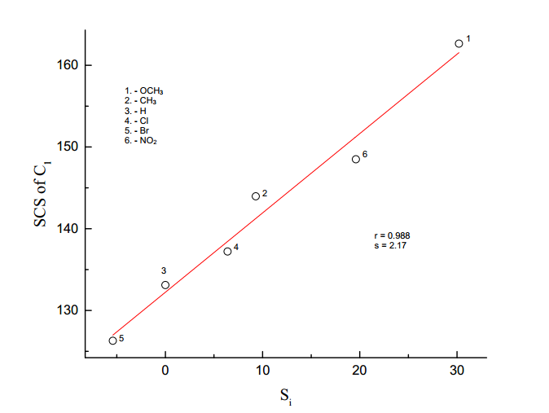

SCS of C4′

**Figure 3.5.** Lynch plot of SCS of C4′ vs Si

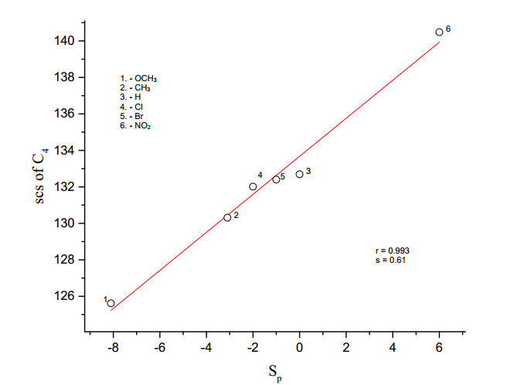

SCS of C1′

**Figure 3.6.** Lynch plot of SCS of C1′ vs Sp

In this chapter, the 13C chemical shift data (Table 3.6) of several carbon atoms of 5-benzylidenebarbituric acid has been correlated with SSP equation (Eq.3.1), DSP equation (Eq.3.2) and Yukawa-Tsuno equation (Eq.3.3)

**3.4.2.2 C1′ - Carbon atom**

The Chemical shift of C1′ carbon (Table 3.6) appeared over a relatively narrow range of 16.24 ppm. The result of SSP analysis shown in the Table (3.7) an excellent correlation affords by σp+ / σp- constant given in equation (3.17), and the plot of log δ C1′ vs σp+ / σp-  is shown in Fig (3.7).

log δ C1′ = 0.024 σp+ / σp- + 2.118 (3.17)

(±0.002) (±0.001)

r = 0.989; s = 0.003; n = 7

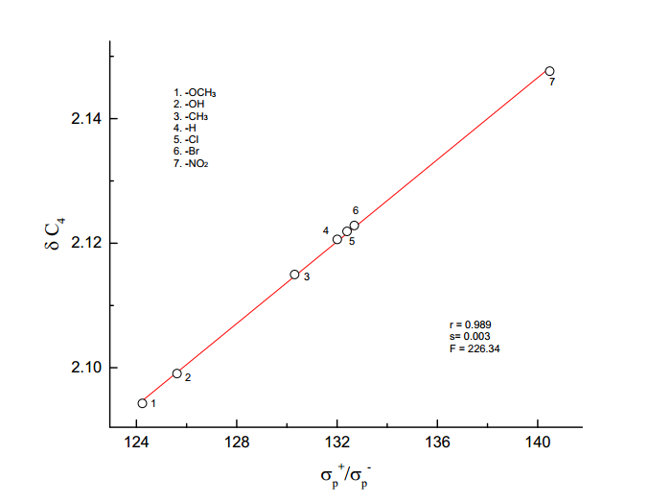

log δ C1′

**Figure 3.7** The plot of log δ C1′  vs σp+ / σp-

The result of DSP analysis in Table (3.8), affords an excellent correlation and are shown in equations (3.18) and (3.19).

log δ C1′ = 0.024σI + 0.051σR + 2.122 (3.18)

(±0.003) (±0.003) (±0. 001)

R = 0.995; SE = 0.002; n = 6: F = 154.44

log δ C1′ = 0.025 F + 0.054 R + 2.123 (3.19)

(±0.003) (±0.002) (±0.001)

R = 0.996; SE = 0.002; n = 7; F = 279.61

The sign of *ρ*I and *ρ*R are positive and reveals that the normal substituent effect operates on C1′ carbon atom, i.e., an electron withdrawing substituent decreases the C1′ carbon atom shielding and an electron releasing substituent increases it. Examination of chemical shift data in the Table (3.6), electron withdrawing substituent causes down field shift and electron releasing substituent causes up field. The magnitude of *ρ*R is greater than *ρ*I it indicates the predominance of resonance effect over inductive effect in the chemical shift of C1′ carbon atom.

This result is also shown by Yukawa-Tsuno equation (3.3) is given in Table (3.9). The result of best fit equation (3.3) is given in equation (3.20)

log δ C1′ = 0.028 σp + 0.032 (σp+- σp) + 2.12 (3.20)

(±0.006) (±0.009) (±0.002)

R = 0.986; SE = 0.003; n = 7; F = 72.76

**Table 3.6:** 13C NMR chemical shifts of 4′-substituted 5-benzylidenebarbituric

acids

|  |  |  |  |  |  |  |  |
| --- | --- | --- | --- | --- | --- | --- | --- |
| **S.No.** | *p*-X | **C1′** | **C3′5′** | **C4** | **C5** | **C6** | **C7** |
|  |  |  |  |  |  |  |  |
| 1 | -OCH3 | 125.62 | 114.41 | 164.39 | 116.00 | 163.92 | 155.46 |
|  |  |  |  |  |  |  |  |
| 2 | -OH | 124.24 | 115.97 | 164.59 | 114.61 | 162.75 | 156.05 |
|  |  |  |  |  |  |  |  |
| 3 | -CH3 | 130.31 | 129.33 | 164.08 | 118.3 | 162.26 | 155.46 |
|  |  |  |  |  |  |  |  |
| 4 | -H | 132.69 | 128.52 | 163.87 | 119.55 | 162.03 | 155.2 |
|  |  |  |  |  |  |  |  |
| 5 | -Cl | 132.01 | 128.55 | 163.67 | 120.09 | 162.04 | 153.52 |
|  |  |  |  |  |  |  |  |
| 6 | -Br | 132.4 | 131.51 | 163.67 | 120.24 | 162.04 | 153.56 |
|  |  |  |  |  |  |  |  |
| 7 | -NO2 | 140.48 | 132.69 | 163.13 | 123.15 | 161.62 | 151.63 |

**Table 3.7:** Results of statistical treatment of 13C – Chemical shift with σp, σpo,

σp+, σp+/ σp, σp+/ σp-,σp+/ σp/ σp-substituent constants using single

parameter equation (3.1)

|  |  |  |  |  |  |  |  |  |
| --- | --- | --- | --- | --- | --- | --- | --- | --- |
| **S.No.** | **Carbons** | **Scale** | **ρ** | **r** | **s** | **F** | **log δo** | **n** |
|  |  |  |  |  |  |  |  |  |
|  |  |  |  |  |  |  |  |  |
| 1 | C1′ | *σp* | 0.043±0.006 | 0.949 | 0.006 | 43.33 | 2.115±0.002 | 7 |
|  | *σpO* | 0.038±0.010 | 0.882 | 0.008 | 13.99 | 2.114±0.004 | 6 |
|  | *σp+* | 0.029±0.002 | 0.986 | 0.003 | 179.37 | 2.121±0.001 | 7 |
|  | *σp+/ σp* | 0.033±0.006 | 0.924 | 0.007 | 29.11 | 2.117±0.003 | 7 |
|  | *σp+/ σp-* | 0.024±0.002 | 0.989 | 0.003 | 226.34 | 2.118±0.001 | 7 |
|  | *σp+/ σp/ σp-* | 0.026±0.004 | 0.938 | 0.006 | 37.12 | 2.115±0.002 | 7 |
|  |  |  |  |  |  |  |  |  |
| 2 | C4 | *σp* | -0.003±0.001 | 0.979 | 0.0003 | 116.72 | 2.24±0.001 | 7 |
|  |  | *σpO* | -0.003±0.001 | 0.945 | 0.0004 | 33.30 | 2.215±0.001 | 6 |
|  |  | *σp+* | -0.002±0.001 | 0.996 | 0.0001 | 640.41 | 2.214±0.001 | 7 |
|  |  | *σp+/ σp* | -0.002±0.001 | 0.935 | 0.0005 | 34.80 | 2.214±0.001 | 7 |
|  |  | *σp+/ σp-* | -0.002±0.001 | 0.983 | 0.0003 | 145.26 | 2.214±.0001 | 7 |
|  |  | *σp+/ σp/ σp-* | -0.002±0.001 | 0.930 | 0.0005 | 32.23 | 2.215±0.001 | 7 |
|  |  |  |  |  |  |  |  |  |
| 3 | C5 | *σp* | 0.025±0.004 | 0.950 | 0.004 | 45.95 | 2.073±0.001 | 7 |
|  | *σpO* | 0.021±0.005 | 0.900 | 0.004 | 17.16 | 2.073±0.002 | 6 |
|  | *σp+* | 0.018±0.001 | 0.995 | 0.001 | 508.52 | 2.077±0.001 | 7 |
|  | *σp+/ σp* | 0.019±0.003 | 0.917 | 0.005 | 26.46 | 2.075±0.002 | 7 |
|  | *σp+/ σp-* | 0.014±0.002 | 0.970 | 0.003 | 80.18 | 2.075±0.001 | 7 |
|  | *σp+/ σp/ σp-* | 0.015±0.003 | 0.902 | 0.005 | 21.75 | 2.075±0.002 | 7 |
|  |  |  |  |  |  |  |  |  |
| 4 | C6 | *σp* | -0.004±0.002 | 0.722 | 0.001 | 5.43 | 2.211±0.001 | 7 |
|  | *σpO* | -0.004±0.002 | 0.620 | 0.002 | 2.51 | 2.211±0.001 | 6 |
|  | *σp+* | -0.003±0.001 | 0.820 | 0.001 | 10.24 | 2.210±0.001 | 7 |
|  | *σp+/ σp* | -0.004±0.001 | 0.917 | 0.001 | 26.41 | 2.210±0.001 | 7 |
|  | *σp+/ σp-* | -0.002±0.001 | 0.775 | 0.001 | 7.51 | 2.210±0.001 | 7 |
|  | *σp+/ σp/ σp-* | -0.003±0.001 | 0.836 | 0.001 | 11.63 | 2.210±0.001 | 7 |
|  |  |  |  |  |  |  |  |  |
| 5 | C7 | *σp* | -0.011±0.001 | 0.984 | 0.001 | 152.18 | 2.189±0.001 | 7 |
|  | *σpO* | -0.015±0.001 | 0.988 | 0.001 | 163.39 | 2.190±0.001 | 6 |
|  | *σp+* | -0.007±0.001 | 0.916 | 0.002 | 25.94 | 2.187±0.001 | 7 |
|  | *σp+/ σp* | -0.008±0.002 | 0.887 | 0.002 | 18.40 | 2.188±0.001 | 7 |
|  | *σp+/ σp-* | -0.006±0.001 | 0.938 | 0.002 | 36.47 | 2.188±0.001 | 7 |
|  | *σp+/ σp/ σp-* | -0.006±0.001 | 0.917 | 0.002 | 26.68 | 2.189±0.001 | 7 |
|  |  |  |  |  |  |  |  |  |
| 6 | C3′5′ | *σo* | 0.044±0.024 | 0.632 | 0.02 | 3.33 | 2.094±0.008 | 7 |
|  | *σo\** | 0.038±0.020 | 0.691 | 0.02 | 3.66 | 2.095±0.009 | 6 |
|  | *Es* | -0.042±0.013 | 0.825 | 0.016 | 10.69 | 2.103±0.006 | 7 |

“n=6 means calculated without -OH group”

**Table 3.8:** DSP analysis of chemical shift data with dual parameter equation (3.2).

|  |  |  |  |  |  |  |  |  |  |  |
| --- | --- | --- | --- | --- | --- | --- | --- | --- | --- | --- |
| **S.No** | **Carbons** | **Scale** | ***ρI*** | ***ρR*** | **R** | **SE** | **F** | **log δo** | **n** | **λ=*ρR*/*ρI*** |
|
| 1 | C1′ | *σI ,σR* | 0.024±0.003 | 0.051±0.003 | 0.995 | 0.002 | 154.44 | 2.122±0.001 | 6 | 0.25 |
|  |  | *σI ,σRo* | 0.032±0.017 | 0.036±0.017 | 0.849 | 0.01 | 3.89 | 2.118±0.007 | 6 | 1.33 |
|  |  | *σI ,σR+* | 0.010±0.030 | 0.018±0.016 | 0.640 | 0.016 | 1.39 | 2.122±0.015 | 7 | 1.80 |
|  |  | *σI ,σR-* | 0.019±0.011 | 0.037±0.009 | 0.943 | 0.007 | 12.10 | 2.120±0.005 | 6 | 2.00 |
|  |  | *F,R* | 0.025±0.003 | 0.054±0.002 | 0.996 | 0.002 | 279.61 | 2.123±0.001 | 7 | 2.00 |
|  |  |  |  |  |  |  |  |  |  |  |
| 5 | C4 | *σI ,σR* | -0.003±0.001 | -0.003±0.001 | 0.998 | 0.0001 | 341.86 | 2.214±0.001 | 6 | 1.50 |
|  |  | *σI ,σRo* | -0.003±0.001 | -0.002±0.001 | 0.859 | 0.0007 | 4.22 | 2.214±0.001 | 6 | 0.66 |
|  |  | *F,R* | -0.002±0.001 | -0.004±0.001 | 0.993 | 0.002 | 152.18 | 2.214±0.001 | 7 | 2.00 |
|  |  |  |  |  |  |  |  |  |  |  |
| 3 | C5 | *σI ,σR* | 0.016±0.002 | 0.026±0.002 | 0.996 | 0.001 | 176.46 | 2.077±0.001 | 6 | 1.63 |
|  |  | *σI ,σRo* | 0.019±0.010 | 0.016±0.010 | 0.810 | 0.006 | 2.86 | 2.074±0.004 | 6 | 0.80 |
|  |  | *σI ,σR+* | 0.008±0.019 | 0.010±0.009 | 0.636 | 0.01 | 1.36 | 2.076±0.009 | 7 | 1.25 |
|  |  | *σI ,σR-* | 0.014±0.008 | 0.017±0.007 | 0.885 | 0.005 | 5.43 | 2.075±0.003 | 6 | 1.21 |
|  |  | *F,R* | 0.015±0.003 | 0.032±0.002 | 0.990 | 0.002 | 105.40 | 2.078±0.001 | 7 | 2.13 |
|  |  |  |  |  |  |  |  |  |  |  |
| 4 | C6 | *σI ,σR* | -0.001±0.001 | -0.008±0.002 | 0.928 | 0.001 | 9.34 | 2.209±0.001 | 6 | 2.00 |
|  |  | *σI ,σRo* | -0.002±0.003 | -0.004±0.003 | 0.550 | 0.002 | 0.649 | 2.210±0.002 | 6 | 2.00 |
|  |  | *σI ,σR+* | 0.001±0.002 | -0.003±0.002 | 0.669 | 0.002 | 1.618 | 2.208±0.002 | 7 | 0.21 |
|  |  | *σI ,σR-* | -0.001±0.001 | -0.004±0.003 | 0.648 | 0.002 | 1.087 | 2.210±0.001 | 6 | 4.00 |
|  |  | *F,R* | -0.001±0.002 | -0.005±0.002 | 0.806 | 0.001 | 3.719 | 2.209±0.001 | 7 | 5.00 |
|  |  |  |  |  |  |  |  |  |  |  |
| 5 | C7 | *σI ,σR* | -0.013±0.001 | -0.007±0.001 | 0.998 | 0.0003 | 349.25 | 2.191±0.001 | 6 | 0.70 |
|  |  | *σI ,σRo* | -0.014±0.003 | -0.005±0.002 | 0.956 | 0.002 | 16.09 | 2.191±0.001 | 6 | 0.36 |
|  |  | *σI ,σR+* | -0.011±0.006 | -0.002±0.001 | 0.838 | 0.003 | 4.74 | 2.191±0.003 | 7 | 0.20 |
|  |  | *σI ,σR-* | -0.012±0.002 | -0.005±0.001 | 0.980 | 0.001 | 36.20 | 2.191±0.001 | 6 | 0.42 |
|  |  | *F,R* | -0.014±0.001 | -0.009±0.001 | 0.993 | 0.001 | 146.55 | 2.191±0.001 | 7 | 0.71 |
|  |  |  |  |  |  |  |  |  |  |  |
| 6 | C3′5′ | *σI ,σR* | 0.010±0.022 | 0.079±0.020 | 0.891 | 0.01 | 5.81 | 2.115±0.010 | 6 | 8.00 |
|  |  | *σI ,σRo* | 0.020±0.001 | 0.031±0.042 | 0.438 | 0.03 | 0.35 | 2.104±0.018 | 6 | 1.50 |
|  |  | *F,R* | 0.006±0.019 | 0.081±0.024 | 0.903 | 0.01 | 8.85 | 2.117±0.010 | 7 | 1.33 |

“n=6 means calculated without -OH group”

**Table 3.9:** Results of multiple regression analysis of 13C chemical shifts with σp,( σp+- σp)  and σpo,

(σp+- σpo) constants using Yukava – Tsuno equation (3.3).

|  |  |  |  |  |  |  |  |  |
| --- | --- | --- | --- | --- | --- | --- | --- | --- |
| **S.No.** | **Carbon** | **scale** | **ρ** | **r** | **R** | **SE** | **F** | **n** |
| 1. | C1′ | *σp,( σp+- σp)* | 0.028±0.006 | 0.032±0.009 | 0.986 | 0.003 | 72.76 | 7 |
|  |  | *σpo,( σp+- σpo)* | 0.027±0.009 | 0.020±0.009 | 0.954 | 0.006 | 15.15 | 6 |
|  |  |  |  |  |  |  |  |  |
| 2. | C4 | *σp,( σp+- σp)* | -0.003±0.001 | -0.002±0.001 | 0.998 | 0.001 | 518.04 | 7 |
|  |  | *σpo,( σp+- σpo)* | -0.002±0.001 | -0.001±0.001 | 0.994 | 0.001 | 133.10 | 6 |
|  |  |  |  |  |  |  |  |  |
| 3. | C5 | *σp,( σp+- σp)* | 0.016±0.002 | 0.021±0.003 | 0.996 | 0.001 | 274.61 | 7 |
|  |  | *σpo,( σp+- σpo)* | 0.014±0.002 | 0.012±0.003 | 0.989 | 0.002 | 65.94 | 6 |
|  |  |  |  |  |  |  |  |  |
| 4. | C6 | *σp,( σp+- σp)* | -0.007±0.002 | -0.006±0.003 | 0.866 | 0.001 | 6.01 | 7 |
|  |  | *σpo,( σp+- σpo)* | -0.001±0.001 | -0.005±0.001 | 0.937 | 0.001 | 10.76 | 6 |
|  |  |  |  |  |  |  |  |  |
| 5. | C7 | *σp,( σp+- σp)* | -0.013±0.001 | 0.004±0.002 | 0.994 | 0.001 | 167.30 | 7 |
|  |  | *σpo,( σp+- σpo)* | -0.012±0.001 | -0.001±0.001 | 0.988 | 0.001 | 61.27 | 6 |

“n=6 means calculated without -OH group”

**3.4.2.3 C4 – Carbon atom**

The chemical shift of C4 carbon appeared over a relatively narrow range of 1.46 ppm. The SSP analysis with various σ parameters, *σp+* gave excellent correlation, and the results are shown in the Table (3.7). It gave negative correlation (Eq.3.21) and the negative slope indicates that a reverse substituent effect operates on the C4 carbon. The Hammett plot of log δ C4 vs *σp+* is shown in Figure (3.8).

log δ C4 = -0.002*σp+* + 2.214 (3.21)

(±0.001) (±0.001)

Examination of chemical shift data in the Table (4.6) shows that the electron releasing substituent causes down field shift while electron-withdrawing substituent causes up field shift. The DSP analysis of C4 carbon with various *σR* scale is given in Table (3.8), the best fit is given in equations (3.22) and (3.23).

log δ C4 = -0.003*σI*  - 0.003 *σR* + 2.214 (3.22)

(±0.001) (±0.001) (±0.001)

R = 0.998; SE = 0.0001; F = 341.86; n =6

log δ C4 = -0.002*F*  - 0.004 *R* + 2.214 (3.23)

(±0.001) (±0.001) (±0.001)

R = 0.993; SE = 0.002; F = 152.18; n = 7

The result of Yukawa-Tsuno equation (3.3), is given in Table (3.9) also indicates that the magnitude of ‘r’ is very low (<1). The best fit is given in equation (3.24).

log δ C4 = -0.003 *σp*  - 0.00 (*σp+- σp*) + 2.214 (3.24)

(±0.001) (±0.001) (±0.001)

R = 0.993; SE = 0.002; F = 152.18; n = 7

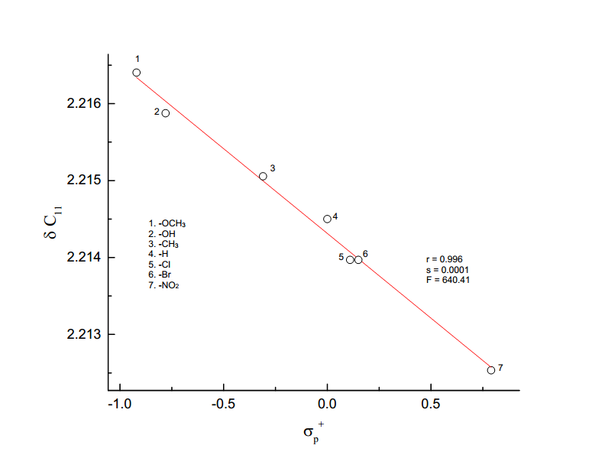

2.214

log δ C4

log

**Figure 3.8** The plot of log δ C4 vs *σp+*

**3.4.2.4 C5 – Carbon atom**

The chemical shift of C5 carbon atom appeared over a relatively narrow range of 7.15 ppm. The results of SSP analysis are shown in the Table (3.7). An excellent correlation is afforded by σp+ constant given in equation (3.25), and the plot of log δ C5 vs σp+ is shown in Fig. (3.9).

log δ C5 = 0.018 *σp+* + 2.077 (3.25)

(±0.001) (±0.001)

r = 0.995; s = 0.001; n = 7; F = 508.52

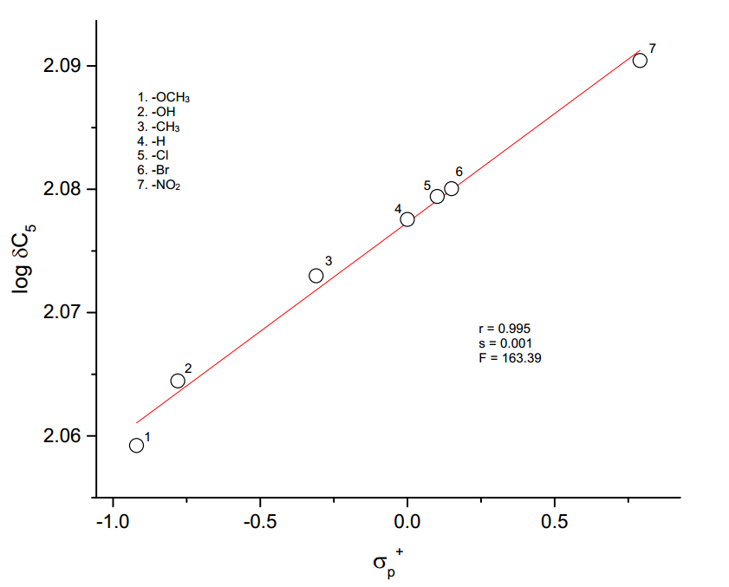

**Figure 3.9** The plot of log δC5 vs *σp+*

The results of DSP analysis in Table (3.8), affords an excellent correlation are shown in equations (3.26) and (3.27).

log δ C5 = 0.016 *σI*+ 0.026 *σR* + 2.077 (3.26)

(±0.002) (±0.002) (0.001)

R = 0.996; SE = 0.001; F = 176.46; n =6

log δ C5 = 0.015*F*+ 0.032 *R* + 2.078 (3.27)

(±0.003) (±0.002) (0.001)

R = 0.990; SE = 0.002; F = 105.40; n =7

The sign of *ρI and ρR* are positive reveals that the normal substituent effect operates on C5 carbon atom, i.e., an electron withdrawing substituent decreases the C6 carbon atom shielding and an electron releasing substituent increases it. The examination of chemical shift data in the Table (3.6), shows that the electron withdrawing substituent causes downfield shift and electron releasing substituent causes upfield. The magnitude of *ρR* greater than*ρI*indicates the predominance of resonance effect over inductive effect in the chemical shift of C5 carbon atom.

The results of Yukawa-Tsuno equation (3.28), also indicate that the magnitude of ‘r’ is very low (<1). The best fit is given in equation (3.28).

log δC5 = 0.016*σp*+ 0.021 (*σp+*- *σp*) + 2.078 (3.28)

(±0.002) (±0.003) (±0.001)

R = 0.996; SE = 0.001; F = 274.61; n =7

**3.4.2.5 C6– Carbon atom**

The chemical shift of C6 carbon atom appeared over a range of about 2.3 ppm. The result of SSP analysis is shown in the Table (3.7); a fairly good correlation afforded by *σp+/σp* constant is given in equation (3.29), and the plot of log δC6 vs σp+/σp is shown in Fig. (3.10). The result is shown in equation (3.29).

log δC6 = -0.004*σp+/σp* + 2.210 (3.29)

(±0.001) (±0.003)

r = 0.917; s = 0.001; F = 26.41; n = 7

The examination of chemical shift data (Table 3.6) of C6 carbon electron-releasing group causes a downfield shift by increasing the shielding and electron withdrawing group causes upfield shift by decreasing the shielding. The DSP analysis of C6 carbon with various *σR* scale is shown in Table (3.8); the best fit is given in Eq.(3.30).

log δC6 = -0.001*σI* - 0.008 *σR* + 2.209 (3.30)

(±0.001) (±0.002) (±0.001)

R = 0.928; SE = 0.001; F = 9.34; n = 6

The result of Yukawa-Tsuno equation (3.3), is given in Table (3.9). The result of the best fit of Eq. (3.3) is given in Eq. (3.31)

log δC6 = -0.001*σpo* - 0.005(*σp+*/ *σpo*) + 2.208 (3.31)

(±0.001) (±0.001) (±0.001)

R = 0.937; SE = 0.001; F = 10.76; n = 6

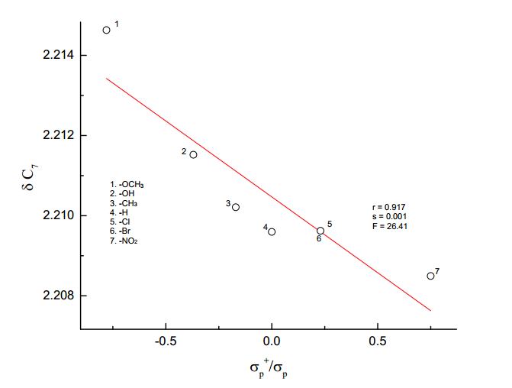

log δC6

log

**Figure 3.10** The plot of log δC6 vs *σp+/σp*

**3.4.2.6 C7- Carbon atom**

The chemical shift of C7 carbon appeared over a relatively narrow range of 4.42 ppm. The SSP analysis with various σ parameters, σpo gave satisfactory correlation; the results are shown in the Table (3.7). It gave negative correlation (Eq.3.32) and the negative slope indicates that a reverse substituent effect operates on the carbonyl carbon. The Hammett plot of log δ C7 vs *σpo* is shown in Figure (3.11).

log δ C7 = -0.015*σpo*  + 2.190 (3.32)

(±0.001) (±0.001)

r = 0.988; s = 0.001; n = 6

Examination of chemical shift data (Table 3.6) of C7 carbon, electron releasing group causes a down field shift by increasing the shielding and electron withdrawing group causes upfield shift by decreasing the shielding.

The DSP analysis of C7 carbon with various σR scale is given in Table (3.8), the best fit is given in equations (3.33) and (3.34)

log δ C7 = -0.013*σI* - 0.007*σR* + 2.191 (3.33)

(±0.001) (±0.001) (0.001)

R = 0.998; SE = 0.0003; n = 6; F = 349.25

log δ C7 = -0.014*F*  - 0.009*R*  + 2.191 (3.34)

(±0.001) (±0.001) (±0.001)

R = 0.993; SE = 0.001; n = 7; F= 146.55

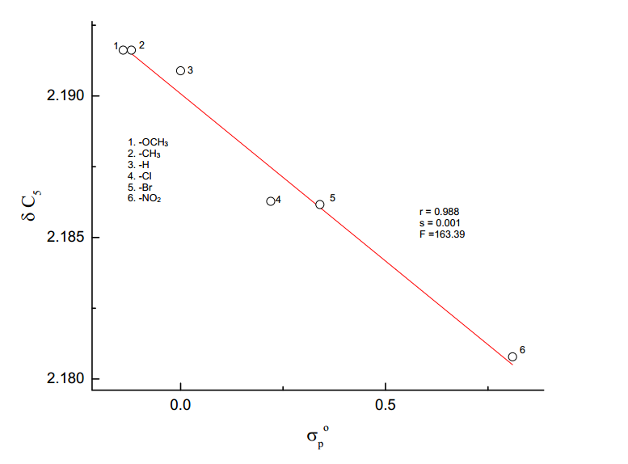

log δC7

log

**Figure 3.11** The plot of log δ C7 vs *σpo*

The sign of slopes *ρI* and *ρR* are negative, which reveals that reverse substituent effect operates on C7 carbon atom.

The results of Yukawa-Tsuno equation (4.35), also indicate that the magnitude of ‘r’ is very low (< 1). The best fit is given in equation (4.35).

log δ C7 = -0.013 *σp* + 0.004 (*σp+- σp*) + 2.190 (3.35)

(±0.001) (±0.002) (±0.004)

R = 0.994; SE = 0.001; n = 7; F = 167.30

**3.4.2.7 C3′5′-Carbon atoms**

The chemical shift of C3′5′carbon atoms appearedover a relativelynarrow range of about 2.116 ppm. In the SSP analysis of C3′5′ *σo,*and *σo*\* gave poor correlation coefficients (r) 0.632 and 0.691 respectively. The results of SSP analysis are given in Eqs. (3.36) and (3.37).

log δ C3′5′ = 0.044 *σo* + 2.094 (3.36)

(±0.024) (±0.008)

r = 0.632; s =0.02; n =7

log δ C3′5′ = 0.038 *σo*\* + 2.095 (3.37)

(±0.020) (±0.009)

r = 0.691; s =0.02; n =6

But the same parameter for *Es* gave satisfactory correlation, given in Eq. (3.38)

log δ C3′5′ = -0.042 *Es* + 2.103 (3.38)

(±0.013) (±0.006)

r = 0.825; s = 0.016; n =7

The best fit for DSP analysis is given in Eqs. (3.39) and (3.40).

log δ C3′5′ = 0.010*σI*  + 0.079*σR* + 2.115 (3.39)

(±0.020) (±0.020) (±0.010)

R = 0.891; SE = 0.01; n = 6

log δ C3′5′ = 0.006 F + 0.081 R + 2.117 (3.40)

(±0.019) (±0.019) (±0.010)

R = 0.903; SE = 0.01; n = 7

**Table 3.10**: TSP analysis of SCS data of C3′5′ carbon atoms of 4′-substituted

5-benzylidenebarbituric acids employing equation (3.4).

|  |  |  |  |  |  |  |  |  |  |
| --- | --- | --- | --- | --- | --- | --- | --- | --- | --- |
|  |  |  |  |  |  |  |  |  |  |
| S.No. | Scale | α | β | φ | R | s | F | PR | PS |
|  |  |  |  |  |  |  |  |  |  |
| 1. | *σI, σR,ν* | 0.019  (±0.045) | 0.084  (±0.034) | -0.007  (±0.029) | 0.895 | 0.016 | 2.68 | 76.4 | 6.40 |
|  |  |  |  |  |  |  |  |  |  |
| 2. | *σI, σRo,ν* | -0.008  (±0.092) | 0.019  (±0.060) | 0.022  (±0.058) | 0.492 | 0.030 | 6.00 | 39.0 | 43.80 |
|  |  |  |  |  |  |  |  |  |  |
| 3. | *σI, σR+,ν* | -0.093  (±0.071) | 0.035  (±0.023) | 0.057  (±0.035) | 0.760 | 0.155 | 1.37 | 19.2 | 31.30 |
|  |  |  |  |  |  |  |  |  |  |
| 4. | *σI, σR-,ν* | 0.006  (±0.085) | 0.039  (±0.058) | 0.001  (±0.063) | 0.595 | 0.030 | 0.36 | 84.7 | 2.17 |
|  |  |  |  |  |  |  |  |  |  |
| 5. | *F, R, ν* | -0.001  (±0.050) | 0.078  (±0.027) | 0.005  (±0.030) | 0.904 | 0.016 | 7.00 | 92.0 | 5.95 |
|  |  |  |  |  |  |  |  |  |  |

The sign of slopes *ρI* and *ρR* are positive and reveals that the normal substituent effects operate on C3’5’ carbon atom. The magnitude of *ρR*is higher than the magnitude of*ρI* and indicates that the resonance effect is predominant over resonance effect on the C3′5′ carbon atom.

The TSP analysis Charton steric parameter (ν) gave poor correlations that are given in Table (3.10). The best fit of TSP analysis is taken from high correlation coefficient (R) and the least standard error (SE) of the regression equation and the results are given in Eqs. (3.41) and (3.42).

log δ C3′5′ = 0.019 *σI*  + 0.084 *σR* - 0.007 ν + 2.117 (3.41)

(±0.045) (±0.034) (±0.029) (±0.015)

R = 0.895; SE = 0.016; n = 6

log δ C3′5′ = -0.001F + 0.078R - 0.005 ν + 2.116 (3.42)

(±0.050) (±0.027) (±0.030) (±0.014)

R = 0.904, s =0.016, n = 7

A better description of the composition of the electrical effect31 is given by the equation (3.43),

PR = (3.43)

PR is the percentage of delocalized effect. The result of TSP analysis given in table (4.10) shows that the delocalized effect is predominant over the localized effect. The magnitude (%) of the steric factor31 is given by the equation (3.44)

PS = (3.44)

The results of the table (3.10) show that steric effect is also operating to some extent.

**3.4.3 Conclusions**

A series of seven numbers of substituted 5-benzylidenebarbituric acids have been synthesized by condensation of barbituric acid with substituted benzaldehydes. These synthesized substituted 5-benzylidenebarbituric acids have been characterized by the 1H and13C spectral data. The 1H and 13C NMR spectral data of these substituted 5-benzylidenebarbituric acids have been correlated with Hammett substituent constants and F and R parameters. From the results of statistical analysis, the effects of the substituent on the spectral data have been studied. The 1H and 13C NMR spectral correlations produced the most number of satisfactory correlations.

**APPENDIX – I**

**Table 3.11:** 13C SCS values for mono substituted benzenes

|  |  |  |  |  |  |
| --- | --- | --- | --- | --- | --- |
| S.No. | Substituents | Z1(Si) | Z2 (So) | Z3 (Sm) | Z4 (Sp) |
|  |  |  |  |  |  |
| 1 | -OCH3 | 30.2 | -14.7 | 0.9 | -8.1 |
|  |  |  |  |  |  |
| 2 | -CH3 | 9.3 | 0.6 | 0 | -3.1 |
|  |  |  |  |  |  |
| 3 | -H | 0 | 0 | 0 | 0 |
|  |  |  |  |  |  |
| 4 | -Cl | 6.4 | 0.2 | 1 | -2 |
|  |  |  |  |  |  |
| 5 | -Br | -5.4 | 3.3 | 2.2 | -1 |
|  |  |  |  |  |  |
| 6 | -NO2 | 19.6 | -5.3 | 0.8 | 6 |
|  |  |  |  |  |  |

**4.4.4 References**

1. D.J. Craik and R.T.C. Brownlee, *Prog.Phys.Org.Chem.*,**14**,1, (1983).
2. N.B. Chapman and J. Shorter (Eds). *Advances in Linear Free Energy*

*Relationships*, Plenum, London, (1972).

1. L.P. Hammett, “*Physical Organic Chemistry*” McGraw Hill Book Company,

Inc., New York, (1970), Chapter VII.

1. J. Shorter, ‘Correlation Analysis in Organic Chemistry, an introduction to

linear free energy relationship’, Clarenden Press, London, (1973).

1. Y. Yukawa and Y. Tsuno, Bull.Chem.Soc.., Japan, **32**, 971, (1959).
2. Fadhil, G.F. and Essa, A.H. *J. Iron. Chem.Soc*., **6**, 808, (2009).
3. R. Arulkumaran, V. Manikandan and G. Thirunarayanan, *World scientific*

*news*, **80**, 235, (2017).

1. R. Arulkumaran, V. Manikandan, P. Christhuraj and G. Thirunarayanan,

*World scientific news*, **62**, 93, (2017).

1. G. Thirunarayanan, K.G. Sekar and R. Lakshmi narayanan, *International*

*Letters of Chemistry, Physics and Astronomy*, **32**, 88, (2014).

1. M. Rajarajan, R. Senbagam, V. Vijayakumar, V. Manikandan, S.Balaji,

G. Vanangamudi and G. Thirukumaran, *World scientific news,* **9,**155, (2015).

11. Aleksandar D. marinkovic, Dominik Brkic, jelena, S.Martinkovic;

Dusanz.Mijin, Milos Milcic and Slobodan D. Petrovic, *Chemical Industry*

*and Chemical Engineering Quarterly*,**19**,67, (2013).

.

1. G. Thirunarayanan, M. Gopalakrishnan, and G. Vanangamudi, *Spectra*

*Chimica Acta*, Part A, **67**,1106, (2007).

1. G. Thirunarayanan, *Bull.Chem. Soc.Ethiop*., **28**,73, (2014).

14. N. Inamoto, K. Kushida, Masuda,H.Ohta, S. Satoh, Y. Tamwa,

Tokomara,K.Tori and M. Yoshida, *Tetrahedran Lett.,* 3617,(1974).

15. J.E. Arrowsmith, M.J. Cook, and D.J. Hardstone, J. *Org.Magn.Reson.,*

**11**,160, (1978).

16. E. Solcaniova, Toma and Gronowitz, *Org.Magn.Reson.,* **8**,439, (1976).

17. M.J. Shapiro, *Tetrahedran*, **33**,1091, (1973).

18. D.A. Dawson, and W.F. Reynolds, *Can.J.Chem.* **53**,373, (1975).

19. D.A.R. Happer, *Aust.J.Chem.*, **53**,373, (1976).

20. D.A.R Happer, S.M. McKerrow, and A.L. Wilkinson, *Aust.J.Chem.*,

**2**,1479, (1973).

21. H. Gunthor, J. Prestein, and P.J. Watan, *Org.Magn.Reson.,***7**,339, (1975).

22. T.A. Modro, W.F. Renolds, and E.S. Kovupowa, *J.Chem.Soc., Perkin*

*Trans.,***2**,1479,(1977).

23. D.A.R. Happer, and.E.Steenson, *J.Chem.Soc.,Perkin Trans.,*,**2**,

843,(1983).

24. Gronowitz, S.; Johnson, A.; Maholanyinova, S.; Tomo and Sokaniova,

*Org.Magn.Reson.,***7**,732, (1975).

25. G.Dana,J.P. Convert, Girault and E.Mathoz, *Can.J.Chem.,***54**,1827,(1976).

26. G.J. Ray, R.J. Kurland, and A.K. Colter, *Tetrahedron,* **27**,735, (1971).

27. J.F. Hinton, and B. Layton, *Org.Magn. Reson.,* **4,353**, (1972).

28. D.J. Craik, in Annual Reports on NMR spectroscopy, ED., G.A. Webb,

*Academic Press*, London, **15**, 1, (1983).

29. B.M. Lynch, *Can. J.Chem.*, **55**,541, (1977).

30. Suppu Perumal, Rama Suppu, Chandrasekeran and Veerappan

Vijayabaskar and David,A. Wilson, *Magn.Reson.chem.,* **33**,779, (1995).

31. M. Charton, *J.Org.Chem*.*,* **40,**407, (1975).